Face Recognition and Finding

M5281054

Eigenface construction:

1. Dataset description and preprocessing:

The dataset contains 400 face images in PGM format

From 40 different people, 10 photos per person

All images need to be converted to grayscale images and uniform size

2. Eigenface construction process:

First read all face images and convert them into one-dimensional vectors

• Calculate the average of these face vectors to get the "average face"

• Subtract the average face from each face image to get the difference vector

• Use PCA (principal component analysis) to calculate the covariance matrix of these

difference vectors

• Extract eigenvectors from the covariance matrix

• Sort by the size of the corresponding eigenvalues and select the first 50 eigenfaces

3. Face reconstruction process:

• Select the face image to be reconstructed

• Subtract the average face from the image

• Project the result into the eigenface space to get the weight coefficient

• Reconstruct the original image with the linear combination of these weight coefficients and eigenfaces

• By adjusting the number of eigenfaces used, the change in reconstruction quality can be observed

4. Experiment

All face images in the dataset

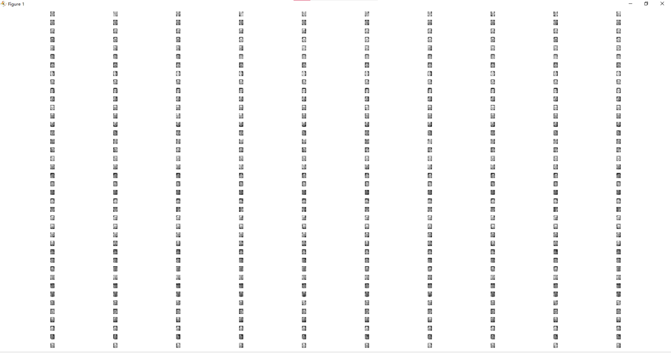

The average face calculated

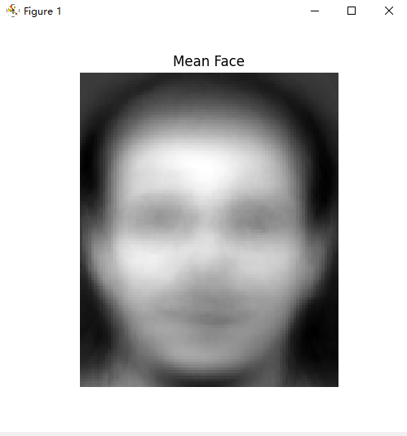

The first 50 eigenfaces

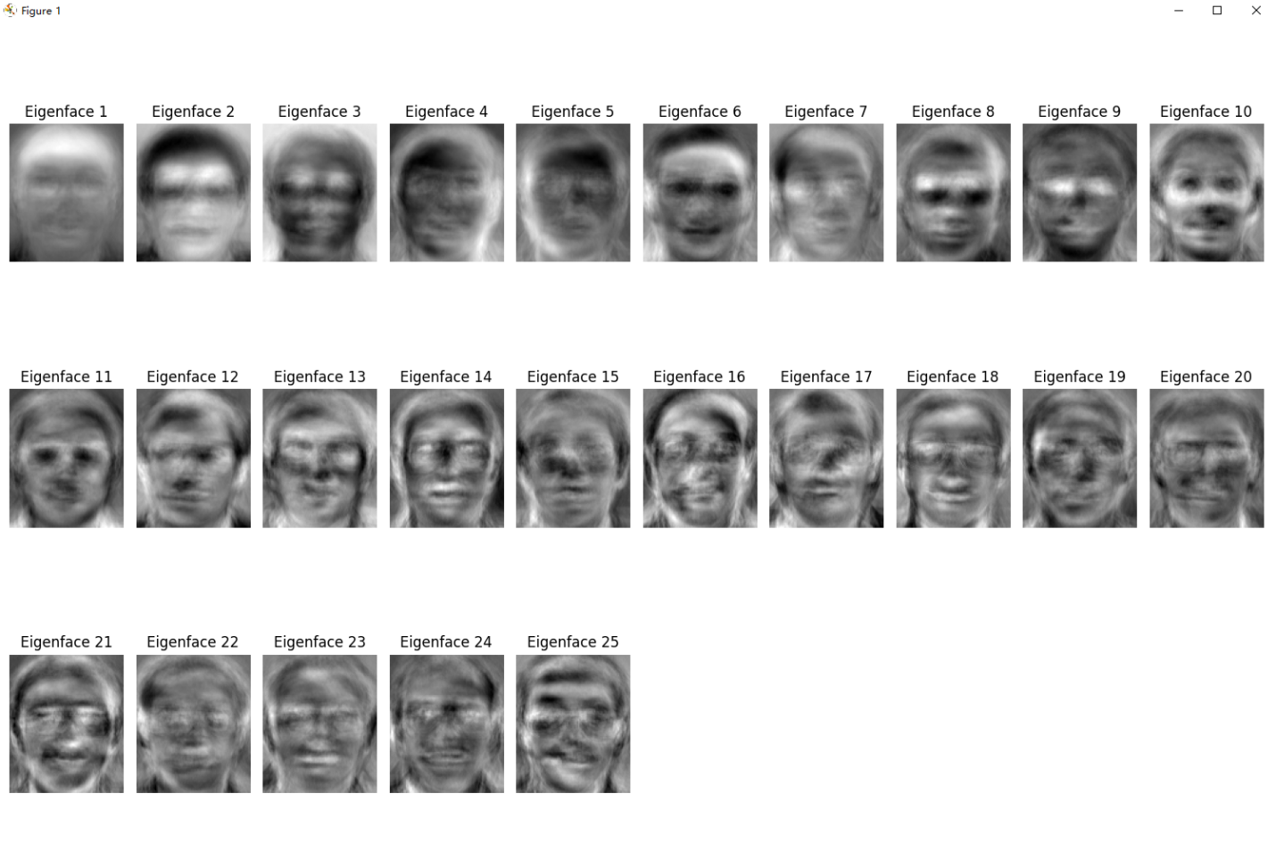Select 3 test images (including 1 with glasses) for reconstruction experiments

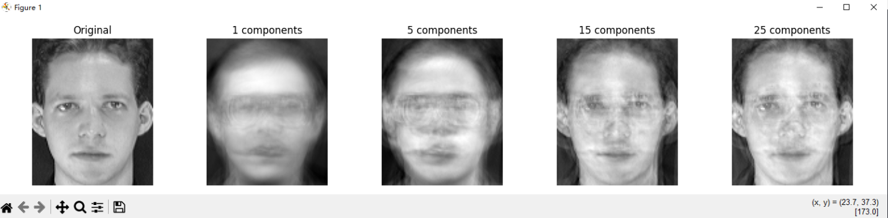

This process is a dimensionality reduction method that can represent and reconstruct facial images with fewer dimensions by finding the most important features in the face image. The quality of reconstruction increases with the number of eigenfaces used, but using too many eigenfaces may introduce noise. Therefore, partial faces are used for construction.

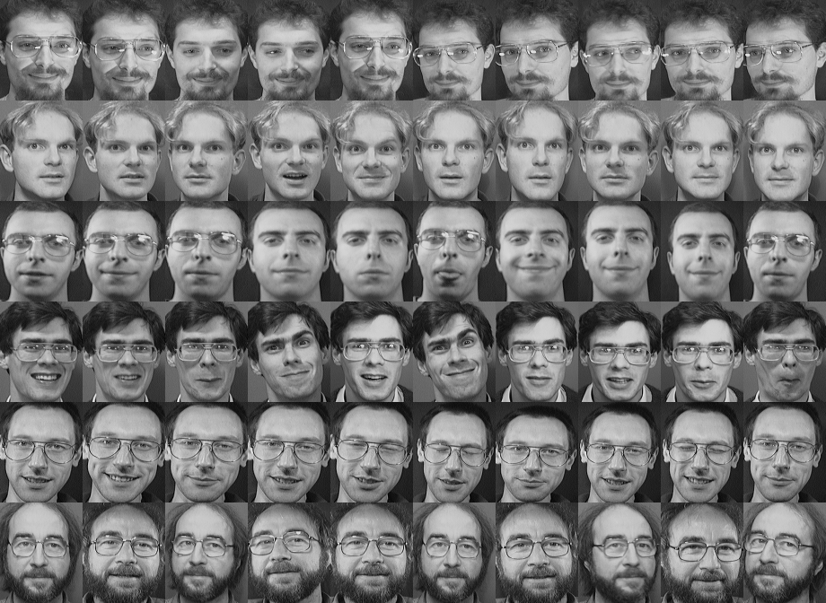

Eigenfaces figure 4：

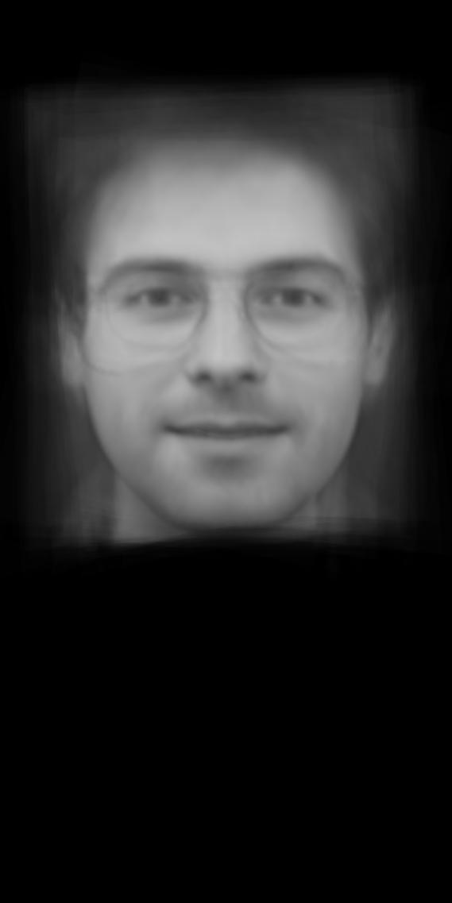

FaceDetector

1. Haar cascade classifier detection:

* Use OpenCV's built-in pre-trained classifier
* Detection via multi-scale sliding windows
* Parameters include: scaling factor, minimum number of neighbors, minimum window size

2. Eigenface method detection:

* Using the generated eigenface space
* Scanning the image through a sliding window
* Calculate the reconstruction error between each window area and the eigenface space
* When the error is less than the threshold, it is determined to be a face area.

3. Experiment

